

**Diagnostic Evidence Co-operative (DEC) Newcastle**

Calculation of age and gender related non-HDL-C percentiles from Health Survey for England data – Implications for diagnosis of Familial Hypercholesterolaemia (FH)

Joy Allen1, Michael Power1, Julie Day2, Jennifer S Mindell3, Shaun Scholes3, Dermot Neely1,2

1 NIHR Diagnostic Evidence Co-operative Newcastle, 2 Department of Clinical Biochemistry, Newcastle upon Tyne Hospitals NHS Foundation Trust, 3Health and Social Surveys Research Group, Research Department of Epidemiology & Public Health, UCL

# Abstract

**Objective -** To develop clinically acceptable charts of lipid values illustrating age and gender specific differences to refine the referral for full genetic testing of possible Familiar Hypercholesterolaemia (FH) patients.

**Background** - Familial Hypercholesterolaemia (FH) is a genetic disorder characterised by high LDL-cholesterol levels causing premature cardiovascular disease. Phenotypic scoring systems such as the Dutch Lipid Clinic Network Score (DLNCS) or the Simon Broome Criteria (SBC) are recommended for selection of patients with a high likelihood of having monogenic FH. These criteria all incorporate the index case’s personal and family history, physical signs and LDL-C concentration. The specific LDL-C thresholds applied are independent of age and gender however, FH diagnosis may be improved by the use of percentile cholesterol thresholds based on nationally-representative population data.

**Methods** – The Health Survey for England data (2003 – 2014) was used to estimate gender specific total and nonHDL Cholesterol age distributions for healthy adults (>16). Using GAMLSS procedures, the authors created smoothed curves demonstrating population based 90th, 97.5th, 99th, 99.5th percentiles.

**Results** - The curves were based on 26,680 adults (>16 years old), 11,495 males and 15,185 females. Curves showed remarkably consistency in shape and magnitude across years for males and females.

**Discussion -** A non-HDL-C concentration of 5.7mmol/L can be considered equivalent to a Friedewald calculated LDL-C of 4.9 mmol/L in patients with a normal fasting triglyceride of ≤1.7 mmol/L. This corresponds to the adult diagnostic threshold for FH according to the SBC and yields a score of 3 in the DLNCS. Our data show that for males aged 35-64, this values lies close to the 90th centile for non-HDL-C but is above the 99th centile for females aged 16-24. The use of this single threshold is likely to lead to under-diagnosis in males <35 and females <45, as well as over-diagnosis in females > 55.

**Conclusions**

Incorporation of age and gender specific non-HDL-C percentiles into UK based FH scoring systems could potentially improve the sensitivity and specificity for FH diagnosis and refine the selection of index cases for targeted genetic testing.

# Introduction

## Methods

This study is based on repeated cross sections of the Health Survey for England (HSE) from 2003 – 2013. HSE is an annual survey which looks at changes in the health and lifestyle of people across England. It includes an in-home questionnaire on a variety of demographics and health topics, and physical measures as well as laboratory measures.

## Sample

We included adults (age > 16) who had at both their total cholesterol (TC) and HDL-C levels available for us to calculate non-HDL-C levels (non-HDL-C = TC – HDL-C). We excluded adults who were known to be taking lipid-lowering medication.

## Laboratory measures

Recalibrate values according to recent notification.

## Statistical Methods

We used the LMS method which is used within the R GAMLSS package. This function uses the Box-Cox Cole and Green (BCCG) distribution for the response variable, non-HDL-C which is similar, but not identical to those used to create age and gender specific childhood growth charts. Sample sizes of 100 at each age point have been recommended for curves such as this.

See Table 1 for sample sizes at each age for men and women. Although sample sizes of less than 100 can be sufficient (REF) this suggests some caution should be used when interpreting data at ages above 78, for men, and 80 for women as the sample sizes for these age groups are small.

## Results

The curves (see Figure 1) were based on 26,680 adults that met the inclusion criteria.

The curves demonstrate peak lipid levels of males aged 40-65 and females aged 65-80.

A non-HDL-C concentration of 5.7mmol/L can be considered equivalent to a Friedewald calculated LDL-C of 4.9 mmol/L in patients with a normal fasting triglyceride of ≤1.7 mmol/L. This has been marked on Figure 1 (top). This demonstrates important differences from currently recommended adult diagnostics threshold for FH of LDL-C of 4.9mmol/L. Males aged 40-70, this values lies close to the 90th centile for non-HDL-C but is above the 99th centile for females aged 16-30. The use of this single threshold is likely to lead to under-diagnosis in males <35 and females <45, as well as over-diagnosis in females > 55.

## Discussion

Our findings confirm previous findings of differences in lipids dependent on age (ref wales score and Starr paper) . We extend these findings using a nationally representative sample of healthy adults and excluding those known to be taking lipid lowering drugs, to create curves to help refine the current clinical diagnosis of FH.

Current established scoring criteria for a clinical diagnosis of FH and referral for genetic testing use a fixed value LDL-C cutoff irrespective of gender or age.

# Tables

Table 1 *Sample size distributions for nonHDL values for men and women at each age*

|  |  |  |  |  |  |  |
| --- | --- | --- | --- | --- | --- | --- |
| **Age** | **Male** | **Female** |  | **Age** | **Male** | **Female** |
| 16 | 138 | 131 |  | 59 | 218 | 290 |
| 17 | 124 | 116 |  | 60 | 228 | 284 |
| 18 | 135 | 105 |  | 61 | 190 | 287 |
| 19 | 83 | 94 |  | 62 | 206 | 233 |
| 20 | 94 | 110 |  | 63 | 167 | 248 |
| 21 | 121 | 140 |  | 64 | 184 | 223 |
| 22 | 113 | 147 |  | 65 | 190 | 233 |
| 23 | 118 | 139 |  | 66 | 184 | 230 |
| 24 | 114 | 152 |  | 67 | 163 | 211 |
| 25 | 129 | 178 |  | 68 | 146 | 188 |
| 26 | 135 | 158 |  | 69 | 145 | 181 |
| 27 | 126 | 191 |  | 70 | 144 | 181 |
| 28 | 157 | 191 |  | 71 | 103 | 163 |
| 29 | 150 | 194 |  | 72 | 90 | 161 |
| 30 | 155 | 213 |  | 73 | 136 | 146 |
| 31 | 131 | 243 |  | 74 | 96 | 123 |
| 32 | 196 | 232 |  | 75 | 93 | 122 |
| 33 | 196 | 273 |  | 76 | 100 | 127 |
| 34 | 193 | 257 |  | 77 | 98 | 111 |
| 35 | 188 | 245 |  | 78 | 67 | 108 |
| 36 | 202 | 280 |  | 79 | 53 | 97 |
| 37 | 216 | 270 |  | 80 | 74 | 85 |
| 38 | 196 | 317 |  | 81 | 58 | 87 |
| 39 | 214 | 313 |  | 82 | 57 | 88 |
| 40 | 220 | 310 |  | 83 | 46 | 73 |
| 41 | 234 | 301 |  | 84 | 39 | 58 |
| 42 | 286 | 328 |  | 85 | 31 | 51 |
| 43 | 270 | 325 |  | 86 | 35 | 50 |
| 44 | 260 | 310 |  | 87 | 26 | 34 |
| 45 | 236 | 344 |  | 88 | 16 | 33 |
| 46 | 218 | 332 |  | 89 | 7 | 23 |
| 47 | 225 | 334 |  | 90 | 13 | 34 |
| 48 | 218 | 285 |  | 91 | 9 | 19 |
| 49 | 228 | 313 |  | 92 | 9 | 15 |
| 50 | 259 | 319 |  | 93 | 5 | 8 |
| 51 | 219 | 297 |  | 94 | 4 | 9 |
| 52 | 248 | 283 |  | 95 | 2 | 1 |
| 53 | 209 | 289 |  | 96 | 1 | 3 |
| 54 | 215 | 290 |  | 97 | 1 | 1 |
| 55 | 238 | 316 |  | 98 | 0 | 3 |
| 56 | 223 | 300 |  | 100 | 0 | 1 |
| 57 | 217 | 319 |  | 104 | 1 | 0 |
| 58 | 213 | 278 |  | **Total** | **11495** | **10562** |

# Figures

Figure 1 *Distribution of non-HDL-C (top) and Total-C (bottom) by gender and age.*

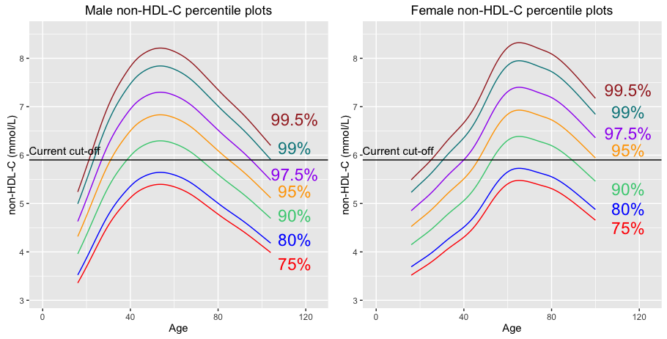

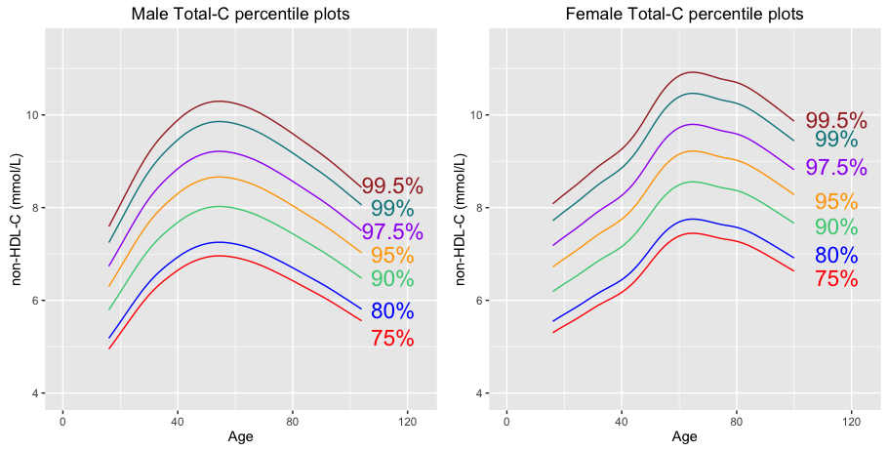

Tables for total C and non-hdl-C like the Starr paper.